Game Design Document

Fill up the following document

1. Write the title of your project.

“Mama, I’m Hungry!”

1. What is the goal of the game?

There will be two dogs trying to eat all the food possible.

1. Write a brief story of your game.

Two hungry dogs found a forest full of yummy food! They want to eat everything because they haven’t eaten in a while. Since, they are so hungry, they want all the food to themselves so they will try eating the most food and try not to get sick.

1. Which are the playing characters of this game?

* Playing characters are the ones who respond to the user based on the input from the user.
* Cars, monkeys, dinos, wizards, etc., are the playing characters in the game.

|  |  |  |
| --- | --- | --- |
| Number | Character Name | What can this character do? |
| 1 | Doggie 1 | This character will collect food and avoid any poisonous foods. |
| 2 | Doggie 2 | This character will collect food and avoid any poisonous foods. |
| 3 |  |  |
| 4 |  |  |
| 5 |  |  |
| 6 |  |  |
| 7 |  |  |
| 8 |  |  |

1. Which are the Non-Playing Characters of this game?

* Non-Playing characters are the ones that don't have an action or behavior when the user interacts with the game.
* Hurdles, stones, bananas, coins, etc., are non-playing characters in the game.

|  |  |  |
| --- | --- | --- |
| Number | Character Name | What can this character do? |
| 1 | Watermelon | This will make the doggies much happier and cure their hunger. |
| 2 | Chocolate | This will make the doggies sick and give them a stomach-ache. |
| 3 |  |  |
| 4 |  |  |
| 5 |  |  |
| 6 |  |  |
| 7 |  |  |
| 8 |  |  |

Draw your imagination of this game. What does this game look like?

* Draw the game either on your computer or on paper.
* Add images of the game scenes to show each of the playing and non-playing characters at least once.

Drawing below, on next page

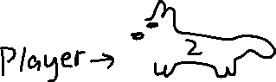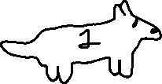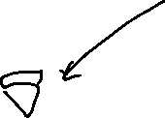

How do you plan to make your game engaging?

I plan to make my game engaging by putting in cute animations and many of both healthy foods and poisonous foods to make the game equally challenging as it is equally as simple.